FILTER FUNCTIONS
NOTE: By using this, manipulate data context and create dynamic calculations.
This function can apply “New Measure”.
Def :
Power Bi by default can perform “Filter” Functions.
Input Data : 1) Filter_tab
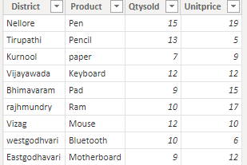
2) customer 3) order
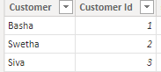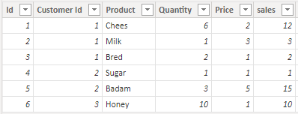
4) filter_blank
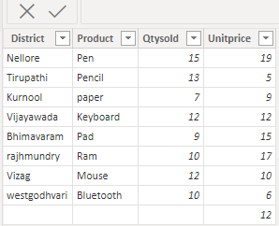

1) ALL: By using this function, we can clear the filters and creating calculations on all the rows in a table or column.
Syntax: ALL( [<table> | <column>[, <column>[, <column>[,…]]]] )
NOTE: Before filtering whatever value is there after filtering that same value will be returned.
In this we can use “calculate” function.
In that conditional filter, we can mention single column, multiple columns as well as table also.
Dax Function: All = CALCULATE(SUM(Filter_tab[Qtysold])*SUM(Filter_tab[Unitprice]),all(Filter_tab[Product]))
Output: 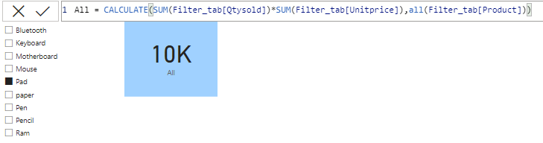
2) ALLCROSSFILTERED: By using this, clear all filters which are applied to a table.
Syntax: ALLCROSSFILTERED(<table>)
NOTE: ALLCROSSFILTERED are same like as All.
Difference between ALL and ALLCROSSFILTERED is,
“ALL” filter based on column name as well as table name also, but “ALLCROSSFILTERED” based on only Table perform filter.
Dax Function: Allcrossfiltered = CALCULATE(SUM(Filter_tab[Qtysold])*SUM(Filter_tab[Unitprice]),ALLCROSSFILTERED(Filter_tab))
Output:
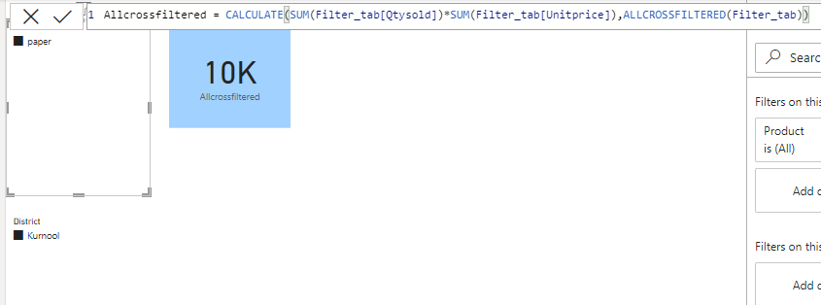
3) ALLEXCEPT: By using this, remove the all context filters in the table except filters that have been applied to the specified columns.
Syntax: ALLEXCEPT(<table>,<column>[,<column>[,…]])
NOTE: This function reverse of “ALL” Filter function.
Dax function: Allexcept = CALCULATE(SUM(Filter_tab[Qtysold])*SUM(Filter_tab[Unitprice]),ALLEXCEPT(Filter_tab,Filter_tab[District]))

Output:
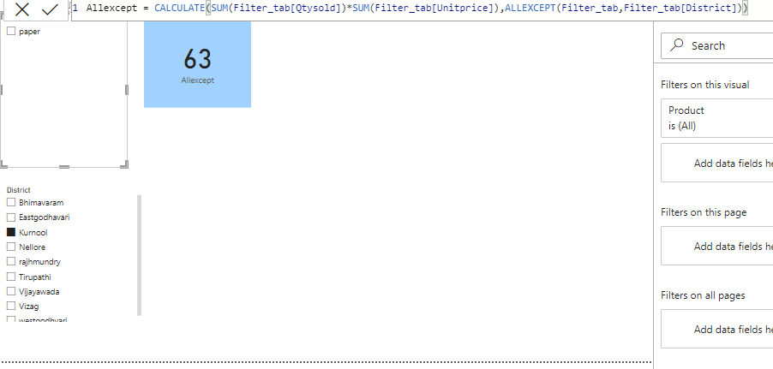
4) ALLNOBLANKROW: By using this function, we can filter only the blank row in the table.
Syntax: ALLNOBLANKROW( {<table> | <column>[, <column>[, <column>[,…]]]} )
Dax Function: earlier = COUNTROWS(ALLNOBLANKROW(filter_blank[Qtysold]))
countrows = COUNTROWS(filter_blank)
Output:
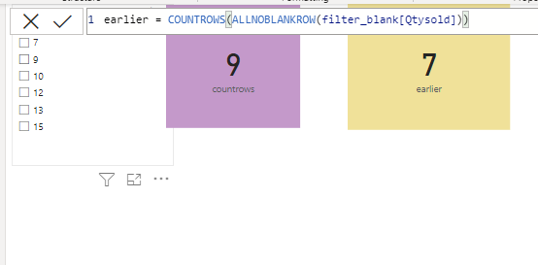

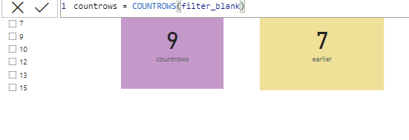

5) ALLSELECTED: By using this, we can clear the filter and creating the calculations.
Syntax: ALLSELECTED([<tableName> | <columnName>[, <columnName>[, <columnName>[,…]]]] )
NOTE: ALLSELECTED function look like this “Default filter”.
But small difference is there, if we want apply any calculated aggregation function on that “ ALLSELECTED” filter function will be used, otherwise these two will provide same result.
Dax Function: Allselected = CALCULATE(SUM(Filter_tab[Qtysold])*SUM(Filter_tab[Unitprice]),ALLSELECTED(Filter_tab))
Output:
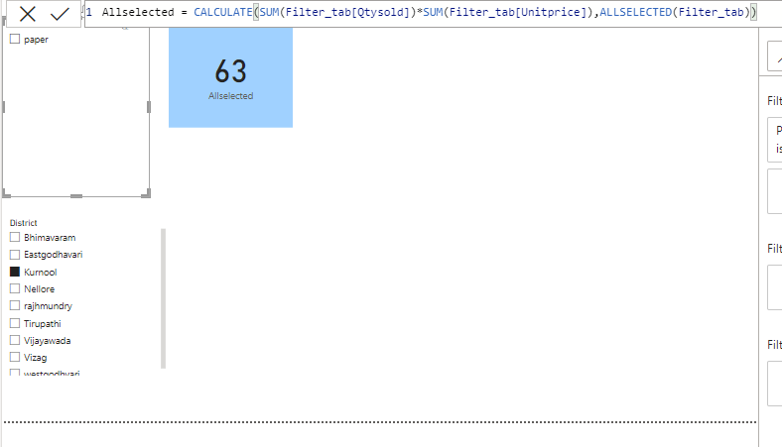
6) CALCULATE: By using this function, evaluate an expression in a modified filter context.
Syntax: CALCULATE(<expression>[, <filter1> [, <filter2> [, …]]])
Dax Function: calculate = CALCULATE(SUM(Filter_tab[Qtysold])*SUM(Filter_tab[Unitprice]))
Output:
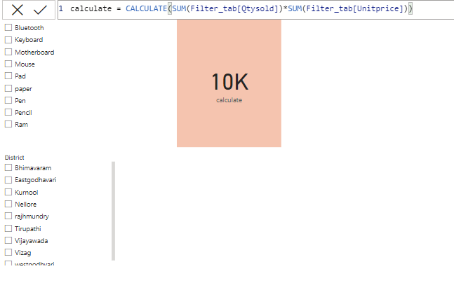
7) SELECTEDVALUE: Is nothing but, in the slicer whatever value you are selected, that value will be picked, otherwise it returns as alternative result.
Syntax: SELECTEDVALUE(<columnName>[, <alternateResult>])
Dax Function: Selectedvalue =
var filter1=SELECTEDVALUE(Filter_tab[District])

return if(filter1=BLANK(),"Notselected",filter1)

Output:
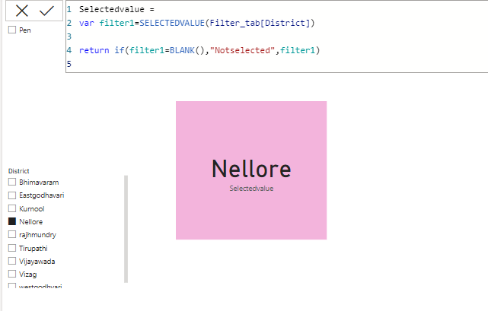
8) FILTER: By using this, if we can write a condition on that time we can use.
Syntax: FILTER(<table>,<filter>)
Dax Function: Filter =
var filter1=SELECTEDVALUE(Filter_tab[District])
var filter2= CALCULATE(SUM(Filter_tab[Qtysold])*SUM(Filter_tab[Unitprice]),FILTER(Filter_tab,Filter_tab[District]=filter1))
return if(filter1=BLANK(),SUM(Filter_tab[Qtysold])*SUM(Filter_tab[Unitprice]),filter2)

Output:
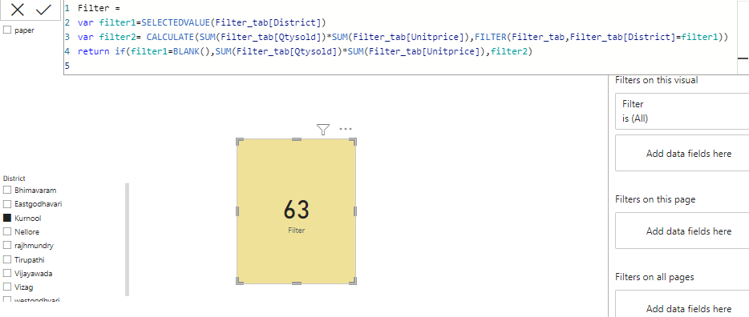
8) KEEPFILTERS: By using this we can clear the filters and create the calculations.
Syntax: KEEPFILTERS(<expression>)
NOTE: It’s just like as a “FILTER” function.

Dax Function: Keepfilter =
CALCULATE(SUM(Filter_tab[Qtysold])*SUM(Filter_tab[Unitprice])
, KEEPFILTERS(Filter_tab[District]="Kurnool"
|| Filter_tab[Product]="paper"
)
)

Output:
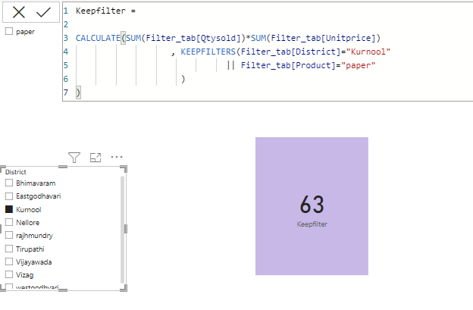
9) REMOVEFILTERS: By using this, we can remove the filters from the specified column or table.
Syntax: REMOVEFILTERS([<table> | <column>[, <column>[, <column>[,…]]]])
Dax Function:
Output:
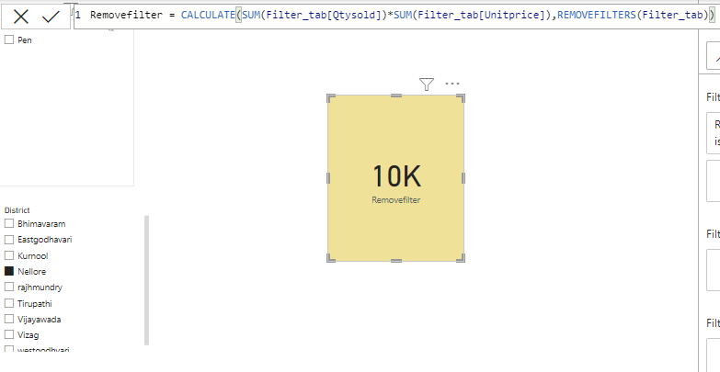
10)LOOKUPVALUE: By using this function, we can get the column name from another table.
NOTE: But in this no certain rules i.e., not compulsory for relationship between dataset and not to satisfy any one cardinality.
Related and Lookupvalue both functions are given same result.
Syntax: LOOKUPVALUE(<result_columnName>,<search_columnName>,<search_value>[, <search2_columnName>, <search2_value>]…[, <alternateResult>])
Dax Function: Customer Name Lookup = LOOKUPVALUE(customer[Customer],customer[Customer Id],'order'[Customer Id])
Output:
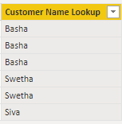
11) EARLIER: By using this we can provide the ranks.
Syntax: EARLIER(<column>, <number>)
NOTE: This function can apply in new column only.
By default check the value is null.
This will be use, for checking the previous value and Running total purpose.
Dax Function: Earlier = CALCULATE(SUM(Filter_tab[Qtysold]),FILTER(Filter_tab,Filter_tab[Qtysold] <= EARLIER(Filter_tab[Qtysold])))

Output:
